**How computers work**: A computer is a machine that follows instructions. It is made out of hardware and software. Hardware is the physical aspect of a computer while the software is made out of everything that tells the computer what to do, like the coding. The motherboard is what everything connects to within the computer making it one of the most important pieces of hardware to the computer. The CPU is also needed because it carries out the demands it’s given, for example, while typing I’m clicking on the keyboard which sends the information to the CPU. For memory, RAM is the system’s short-term memory in which computers temporarily store the data until it’s needed. Additionally, the hard drive is where data such as files are stored for the long term. The video card is responsible for everything we see on the screen.

<https://www.youtube.com/watch?v=1ahZcFzZCEo>

**Describe one of the functions from the video**

The logic unit is the second part of an ALU that performs the logical operations including AND, OR, and NOT and also tests such as checking if numbers negative. An example in the video was the circuit that was used to test if the output number was zero using 7 OR gates to see if any of the bits were one. It then used a NOT gate to flip the input to make it so the output was 1 only if the input number was 0.

* **Charles Babbage’s Analytical Engine –** Charles Babbage’s Analytical Engine would have been the world’s first general-purpose computer. It introduced multiple computing concepts such as something called the store and mill similar to today’s memory and processor. Babbage wanted it to be constructed with brass fittings and powered by steam but never actually got to build it since the government wasn’t willing to fund it. Source: <https://whatis.techtarget.com/definition/Analytical-Engine>

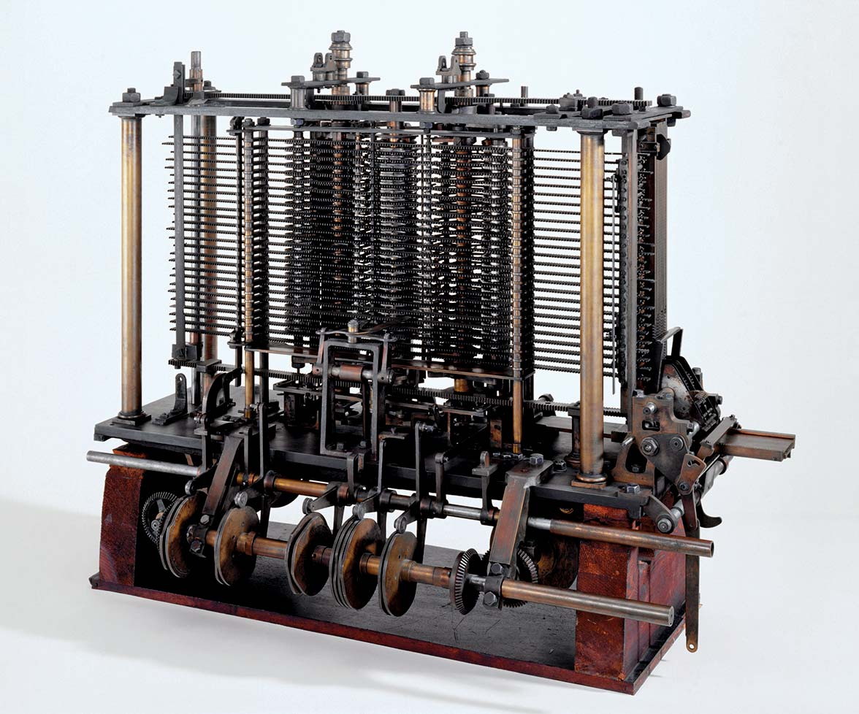

* **ENIAC –** ENIAC, fully called the Electronic Numerical Integrator and Computer was the first programmable general-purpose electronic digital computer. It was built by physicist John Mauchly, engineer J. Presper Eckert, Jr., and others at the Moore School of Electrical Engineering at the University of Pennsylvania. It was funded by the US government as a project to build an all-electronic computer during WW2. Source:<https://www.britannica.com/technology/ENIAC> 